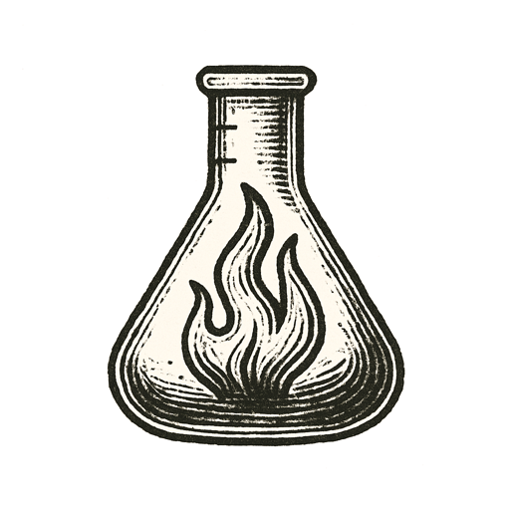
A vial balanced on trembling fingers. Frost crawled across glass.
A sequence glowed on the monitor – letters of life, letters of death.
Breath misted in the sterile air. Eyes scanned columns of nucleotides faster than any mind should dare.
A bead of liquid slipped down the vial’s curve. The hand flinched.
Glass met tile. The shatter cracked like a gunshot.
Silence flooded the room.
Outside, birds sang over traffic. Someone laughed at a café.
A new patient zero took its first breath.

Monsters breathe invisible fire.

